4. CONVERGENCE AND SPACE OF STATES
From the general explicit representation we find the criterion of convergence:
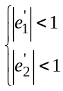 Equ. 4.1
where 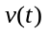and 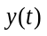are usually true complex numbers. Thus, the whole system can be represented in a 5-dimension space 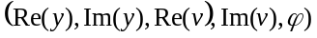.

In this section we study some examples of the most simple class of constricted cases: the ones with just one constriction coefficient. These will allow us to devise methods for controlling the behavior of the swarm in ways that are desirable for optimization.

4.1 Constriction For Model Type 1
Model Type 1 is described as follows:

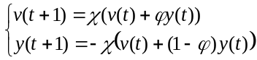 Equ. 4.2

We have seen that the convergence criterion is satisfied when 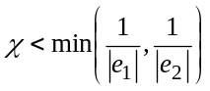. Since 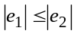 the constriction coefficient below is produced:
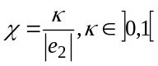 Equ. 4.3

4.2 Constriction for model Type 1'
Just as a constriction coefficient was found for the Type 1 model, the following implicit representation (with χ instead of α) is used for Type 1':

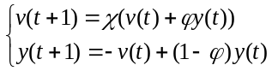 Equ.4.4

The coefficient becomes
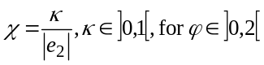 . Equ.4.5
But, as seen above, this formula is a priori valid only when ϕ<2, so it is interesting to find another constriction coefficient that has desirable convergence properties. We have here

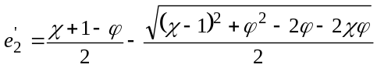 Equ.4.6

The expression under the square root is negative for 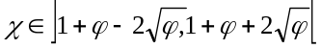. In this case, the eigenvalue is a true complex number, and 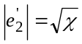. Thus, if 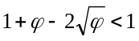, that is to say if ϕ<4, a χ needs to be selected such that 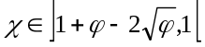 in order to satisfy the convergence criterion. So, for example, define χ as
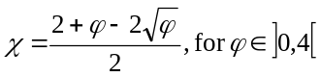 Equ.4.7
Now, can another formula for greater ϕ values be found? The answer is “No”. For in this case, 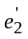 is a real number, and its absolute value is
- strictly decreasing on 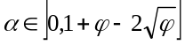, and the minimal value is 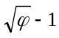 (greater than 1),
- strictly decreasing on 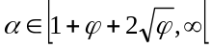, with a limit of 1.

For simplicity, the formula can be the same as for Type 1, not only for ϕ<2, but also for ϕ<4. This is indeed also possible, but then κ can not be too small, depending on ϕ. More precisely, the constraint 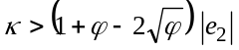 must be satisfied. But as for ϕ<4, we have 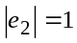, this just means that the curves in Figures 4.1 and 4.2 can then be interpreted as the mean and minimally acceptable χ values for sure convergence. For example, for ϕ=3, the constraint κ>0.536 must hold. But there is no such restriction on 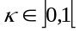if ϕ=1.
- - - - - - - - - - - - - - - - - - - - - - -
Figures 4.1 and 4.2
- - - - - - - - - - - - - - - - - - - - -
Note 4.1
The above analysis is for ϕ=constant. If ϕ is random, it is nevertheless possible to have convergence, even with a small constriction coefficient, when at least one ϕ value is strictly inside the interval of variation.

4.3 Constriction type 1"
Referring to the Class 1" model, in the particular case where 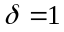, we use the following implicit representation (with χ instead of α)
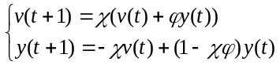 Equ. 4.8

In fact, this system is hardly different from the classical particle swarm as described in the Section 1
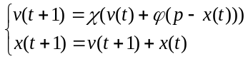 Equ. 4.9
so it may be interesting to detail how, in practice, the constriction coefficient is found and its convergence properties proven.

Step 1. Matrix of the system
We have immediately 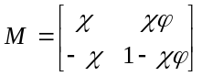. Equ. 4.10

Step 2. Eigenvalues
They are the two solutions for the equation
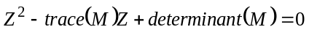 Equ. 4.11
or
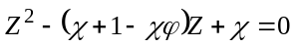 Equ. 4.12
Thus,
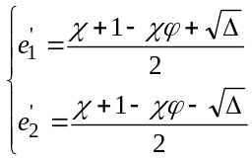 Equ. 4.13
with
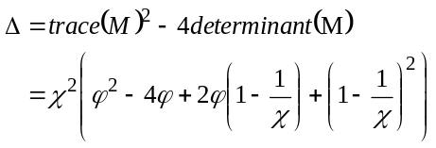 Equ. 4.14

Step 3. Complex and real areas on
The discriminant is negative for the values in 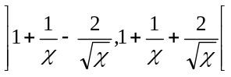. In this area the eigenvalues are true complex numbers and their absolute value (i.e., module) is simply 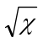.

Step 4. Extension of the complex region and constriction coefficient
In the complex region, according to the convergence criterion,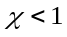 in order to get convergence. So the idea is to find a constriction coefficient depending on so that the eigenvalues are true complex numbers for a large field of values.

This is generally the most difficult step and sometimes needs some intuition. Three pieces of information help us here:
- The determinant of the matrix is equal to ,
- This is the same as in Constriction Type 1, and
- We know from the algebraic point of view the system is (eventually) convergent like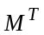

So it appears very probable that the same constriction coefficient used for Type 1 will work. First, we try
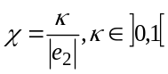 Equ. 4.15

that is to say 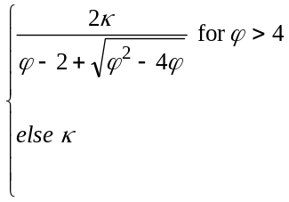 Equ. 4.16
In this case the common absolute value of the eigenvalues is
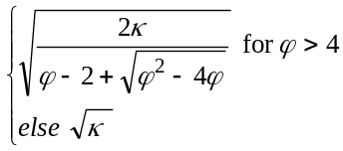 Equ. 4.17

which is smaller than 1 for all values as soon as is itself smaller than 1.

It is easy to see that is negative only between 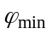 and 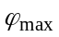, depending on . The general algebraic form of is quite complicated (polynomial in 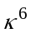with some coefficients being roots of an equation in 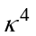) so it is much easier to compute it indirectly for some values. If is smaller than 4, then 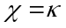and by solving 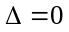 we find that 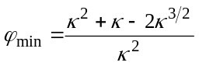. This relation is valid as soon as 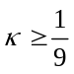. Figure 4.3 shows how the discriminant depends on , for two values. It is negative between the values given below:

0.4 | 0.3377 | 8.07
0.99 | 0.000025 | 39799.76

- - - - - - - - - - - - - - - - - - - - -
Figure 4.3
- - - - - - - - - - - - - - - - - - - - -

4.3 Moderate constriction
While it is desirable for the particle’s trajectory to converge, by relaxing the constriction the particle is allowed to oscillate through the problem space initially, searching for improvement. Therefore it is desirable to constrict the system moderately, preventing explosion while still allowing for exploration. To demonstrate how to produce moderate constriction the following explicit representation is used:

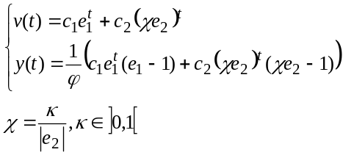 Equ.4.18
that is to say 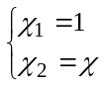. From the relations between ER and IR, the following is obtained:
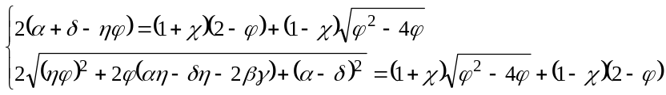 Equ.4.19
There is still an infinity of possibilities for selecting the parameters α..η. In other words there are many different implicit representations that produce the same explicit one. For example:

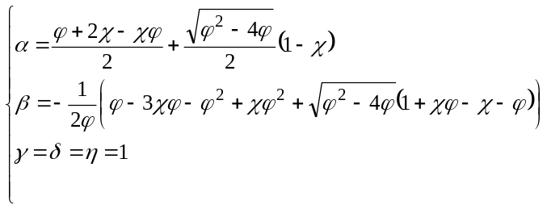 Equ.4.20
or
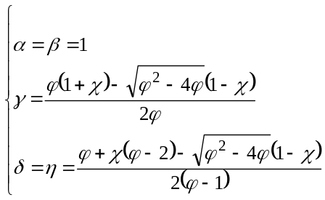 Equ.4.21

From a mathematical point of view, this case is richer than the previous ones. There is no more explosion, but there is not always convergence either. This system is “stabilized,” in the sense that the representative point in the state space tends to move along an attractor which is not always reduced to a single point as in classical convergence.

4.4 Attractors and convergence
Figures 4.4 through 4.7 show the “real” restrictions 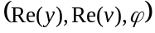 of the particles that are typically studied. We can clearly see the three cases:

- “Spiral” easy convergence towards a nontrivial attractor for ϕ<4 (Figure 4.5),
- Difficult convergence for ϕ≈4 (Figure 4.6), and
- Quick almost linear convergence for ϕ>4 (Figure 4.7).

- - - - - - -- - - - - - - - - - - - - - -- - - -
Figure 4.4
- - - - - - -- - - - - - - - - - - - - - -- - - -
- - - - - - -- - - - - - - - - - - - - - -- - - -
Figure 4.5 - 4.10
- - - - - - -- - - - - - - - - - - - - - -- - - -

Nevertheless, it is interesting to have a look at the true system, including the complex dimensions. Figures 4.8 through 4.11 show some other sections of the whole surface in 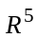.

- - - - - - -- - - - - - - - - - - - - - - - - -
Figure 4.11. Global attractor for v and 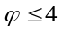. Axis (Re(v), Im(v), ϕ), κ=0.8
- - - - - - -- - - - - - - - - - - - - - -- - - -

Note 4.2
There is a discontinuity, for the radius is equal to zero for ϕ>4.

- - - - - - -- - - - - - - - - - - - - - -- - - -
Figure 4.12
- - - - - - -- - - - - - - - - - - - - - -- - - -

Thus, what it seems to be an “oscillation” in the real space is in fact a continuous spiralic movement in a complex space. More importantly, the attractor is very easy to define: it is the “circle” 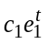 (center (0,0) and radius ρ). When ϕ < 4, 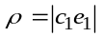 and when ϕ >4, then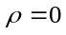(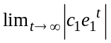 with 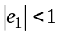), for the constriction coefficient χ has been precisely chosen so that the part 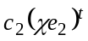 of v(t) tends to zero. This provides an intuitive way to transform this stabilization into a true convergence. We just have to use a second coefficient in order to reduce the attractor, in the case 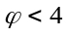, so that
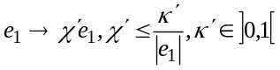 Equ.4.22

The models studied here have only one constriction coefficient. If one sets 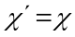, the Type 1 constriction is produced. But now, we understand better why it works.

5. GENERALIZATION OF THE PARTICLE SWARM SYSTEM
Thus far the focus has been on a special version of the particle swarm system, a system reduced to scalars, collapsed terms, and nonprobabilistic behavior. The analytic findings though can easily be generalized to the more usual case where ϕ is random and two vector terms are added to the velocity. In this section the results are generalized back to the original system as defined by
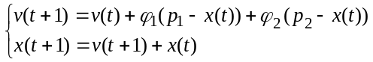 Equ. 5.1

Now ϕ, p, and y(t) are defined to be
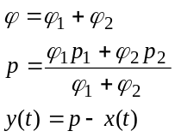 Equ. 5.2

to obtain exactly the original nonrandom system described in Section 1.

For instance, if there is a cycle for 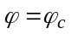, then there is an infinity of cycles for the values 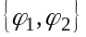 so that 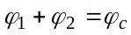.

Upon computing the constriction coefficient, the following form is obtained:
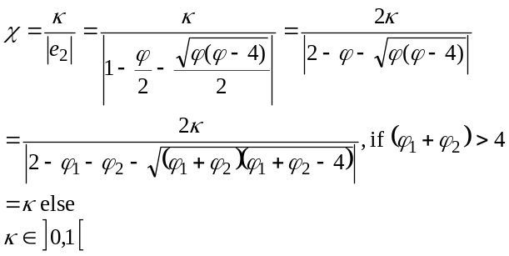 Equ. 5.3

Coming back to the (v,x) system, v and x are

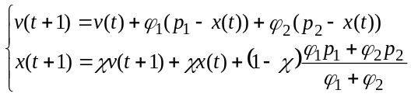 Equ. 5.4

The use of the constriction coefficient can be viewed as a recommendation to the particle to “take smaller steps.” The convergence is towards the point 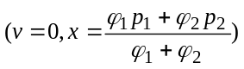. Remember v is in fact the velocity of the particle, so it will indeed be equal to zero in a convergence point.

Example
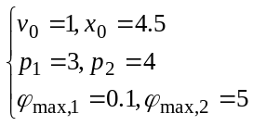

ϕ₁ and ϕ₂ are uniform random variables between 0 and ϕ_{max,1} and ϕ_{max,2} respectively. This example is shown in Figure 5.1.
- - - - - - - - - - - - - - -
Figure 5.1
- - - - - - - - - - - - -

6. RUNNING THE PARTICLE SWARM WITH CONSTRICTION COEFFICIENTS
As a result of the above analysis, the particle swarm algorithm can be conceived of in such a way that the system’s explosion can be controlled, without resorting to the definition of any arbitrary or problem-specific parameters. Not only can explosion be prevented, but the model can be parameterized in such a way that the particle system consistently converges on local optima. (Except for a special class of functions, convergence on global optima cannot be proven.)

The particle swarm algorithm can now be extended to include many types of constriction coefficients. The most general modification of the algorithm for minimization is presented in the following pseudocode:

Assign κ, ϕ_{max}
Calculate χ, α, β, γ, δ, η
Initialize population: random x_{i}, v_{i}

Do
For i=1 to population size

if f(x_{i})<f(p_{i}) then p_{i} = x_{i}

For d=1 to dimension
ϕ1=rand()×(ϕ_{max}/2)
ϕ2=rand()×(ϕ_{max}/2)
ϕ=ϕ1+ϕ2
p=((ϕ1*p_{id})+( ϕ2*p_{gd}))/ ϕ
x=x_{id}
v=v_{id}

v_{id} = α*v + β*ϕ*(p - x)
x_{id} = p + γ*v – (δ - (η*ϕ)) * (p – x)

Next d
Next i
Until termination criterion is met

In this generalized version of the algorithm, the user selects the version and chooses values for κ and ϕ that are consistent with it. Then the two eigenvalues are computed, and the greater one is taken. This operation can be performed as follows:

discrim = 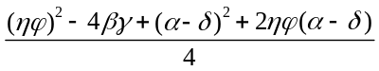
a=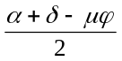
if (discrim>0) then
neprim1=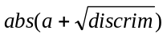
neprim2=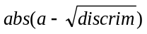
else
neprim1=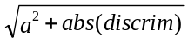
neprim2=neprim1
max(eig.)=max(neprim1, neprim2)

These steps are taken only once in each program, and thus do not slow it down. For the versions tested in this paper, the constriction coefficient is calculated simply as 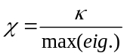. For instance, the Type 1 version is defined by the rules α = β = γ = δ = η = χ.

The generalized description allows the user to control the degree of convergence by setting κ to various values. For instance, in the Type 1″ version, κ=1.0 results in slow convergence, meaning that the space is thoroughly searched before the population collapses into a point.

In fact, the Type 1″ constriction particle swarm can be programmed as a very simple modification to the standard version presented in the Introduction. The constriction coefficient χ is calculated as shown in Equation 4.16:

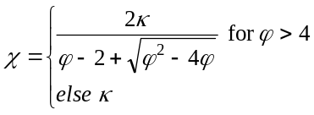

The coefficient is then applied to the right side of the velocity adjustment:

Calculate χ
Initialize population
Do
For i= 1 to Population Size
if f(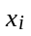)<f(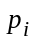) then =
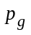=min(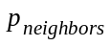)
For d = 1 to Dimension
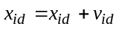
Next d
Next i
Until termination criterion is met

Note that the algorithm now requires no explicit limit 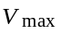. The constriction coefficient makes it unnecessary. Eberhart and Shi (2000) have recommended, based on their experiments, that a liberal , for instance, one that is equal to the dynamic range of the variable, be used in conjunction with the Type 1″ constriction coefficient. Though this extra parameter may enhance performance, the algorithm will still run to convergence even if it is omitted.

7. EMPIRICAL RESULTS
Several types of particle swarms were used to optimize a set of unconstrained real-valued benchmark functions, namely several of De Jong’s (1975) functions, Schaffer’s f6, and the Griewank, Rosenbrock, and Rastrigin functions. A population of 20 particles was run for twenty trials per function, with the best performance evaluation recorded after 2,000 iterations. Some results from Angeline’s (1998) runs using an evolutionary algorithm are shown for comparison.

Though these functions are commonly used as benchmark functions for comparing algorithms, different versions of them have appeared in the literature. The formulas used here for De Jong’s f1, f2, f4 (without noise), f5, and Rastrigin functions are taken from Reynolds and Chung (1997). Schaffer’s f6 function is taken from Davis (1991), 3rd edition; note that earlier editions give a somewhat different formula. The Griewank function given here is the one used in the First International Contest on Evolutionary Optimization held at ICEC 96, and the Rosenbrock function is taken from Angeline (1998).

Table 7.1. Functions used to test the effects of the constriction coefficients.
Sphere function (De Jong’s f1) | 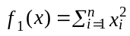
Rosenbrock variant (De Jong’s f2) | 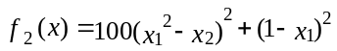
De Jong’s f4 – no noise | 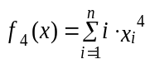
Foxholes (De Jong’s f5) | 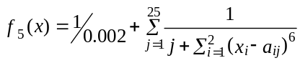
Schaffer’s f6 | 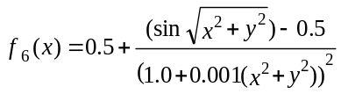
Griewank function | 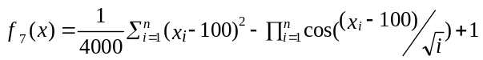
Rosenbrock function | 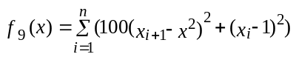
Rastrigin function | 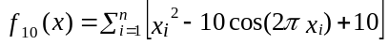

7.1. Algorithm variations used
Three variations of the generalized particle swarm were used on the problem suite.

Type 1. The first version applied the constriction coefficient to all terms of the formula:
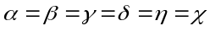
using 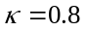.

Type 1″. The second version tested was a simple constriction which was not designed to converge, but not to explode, either, as was assigned a value of 1.0. The model was defined as:
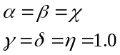

Experimental version. The third version tested was more experimental in nature. The constriction coefficient was initially defined as 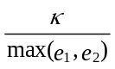. If 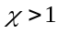 then it was multiplied by 0.9 iteratively until 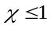. Once a satisfactory value was found, the following model was implemented:
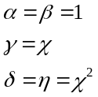
As in the first version, a “generic” value of was used.

Table 7.2 displays the problem-specific parameters implemented in the experimental trials.

Table 7.2 Function parameters for the test problems.
Function | Dimension | Initial Range
1 | 30 | ±20
2 | 2 | ±50
4 | 30 | ±20
5 | 2 | ±50
Shaffer’s f6 | 2 | ±100
Griewank | 30 | ±300
Ackley | 30 | ±32
Rastrigin | 30 | ±5.12
Rosenbrock | 30 | ±10

7.2. Results
Table 7.3, below, compares various constricted particle swarms’ performance to that of the traditional 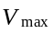 particle swarm and evolutionary optimization (EO) results reported by Angeline (1998). All particle swarm populations comprised 20 individuals.

Functions were implemented in 30 dimensions except for f2, f5, and f6, which are given for two dimensions. In all cases except f5, the globally optimal function result is 0.0. For f5 the best known result is 0.998004. The limit of the control parameter ϕ was set to 4.1 for the constricted versions, and 4.0 for the versions of the particle swarm. The column labeled “E&S” was programmed according to the recommendations of Eberhart and Shi (2000). This condition included both Type 1″ constriction and , with set to the range of the initial domain for the function. Function results were saved with six decimal places of precision.

Table 7.3. Empirical results. Mean best evaluations at the end of 2,000 iterations for various versions of particle swarm and Angeline’s (1998) evolutionary algorithm.
Function | =2 | =4 | Type 1" | Type 1 | Exp. Version | E&S | Angeline (1998)
1 | 15.577775 | 59.301901 | 0 | 0 | 0 | 0 | 9.8808
2 | 0.000500 | 0.0013263 | 0 | 0 | 0 | 0
4 | 271.107996 | 4349.137512 | 0 | 0 | 0 | 0
5 | 2.874299 | 3.564808 | 0.998004 | 0.998004 | 3.507922 | 0.998004
Shaffer’s f6 | 0.000464 | 0.000247 | 0.001459 | 0.002915 | 29.173010 | 0.000155
Griewank | 0.562339 | 0.968623 | 0.003944 | 0.008614 | 0.038923 | 0.002095 | 0.4033
Ackley | 4.287476 | 6.623447 | 0.204988 | 0.150886 | 7.135213 | 0.104323
Rastrigin | 223.834812 | 299.771716 | 82.95618 | 81.689550 | 63.222601 | 57.194136 | 46.4689
Rosenbrock | 2770.882599 | 37111.70703 | 50.193877 | 39.118488 | 47.753953 | 50.798139 | 1610.359

As can be seen, the Type 1" and Type 1 constricted versions outperformed the versions in almost every case; the experimental version was sometimes better, sometimes not. Further, the Type 1" and Type 1 constricted particle swarms performed better than the comparison evolutionary method on three of the four functions; with some caution we can at least consider the performances to be comparable.

Eberhart and Shi’s suggestion to hedge the search by retaining with Type 1" constriction does seem to result in good performance on all functions. It is the best on all except the Rosenbrock function, where performance was still respectable. An analysis of variance was performed comparing the “E&S” version with Type 1", standardizing data within functions. It was found that the algorithm had a significant main effect, F(1, 342)=12.02, p<0.0006, but that there was a significant interaction of algorithm with function, F(8,342)=3.68, p<0.0004, suggesting that the gain may not be robust across all problems. These results support those of Eberhart and Shi (2000).

Any comparison with Angeline’s evolutionary method should be considered cautiously. The comparison is offered only as a prima facie standard by which to assess performances on these functions after this number of iterations. There are numerous versions of the functions reported in the literature, and it is extremely likely that features of the implementation are responsible for some variance in the observed results. The comparison though does allow the reader to confirm that constricted particle swarms are comparable in performance to at least one evolutionary algorithm on these test functions.

As has long been noted, the particle swarm succeeds at finding optimal regions of the search space, but has no feature that enables it to converge on optima (e.g., Angeline, 1998). The constriction techniques reported in this paper solve this problem, they do force convergence. The data clearly indicate an increase in the ability of the algorithm to find optimal points in the search space for these problems as a result.

No algorithmic parameters were adjusted for any of the particle swarm trials. Parameters such as , ϕ, population size, etc. were held constant across functions. Further, it should be emphasized that the population size of 20 is considerably smaller than what is usually seen in evolutionary methods, resulting in fewer function evaluations and consequently faster clock time in order to achieve a similar result. For instance, Angeline’s results cited for comparison are based on populations of 250.

8. CONCLUSIONS
This paper explores how the particle swarm algorithm works from the inside, that is, from the individual particle’s point of view. How a particle searches a complex problem space is analyzed, and improvements to the original algorithm based on this analysis are proposed and tested. Specifically, the application of constriction coefficients allows control over the dynamical characteristics of the particle swarm, including its exploration versus exploitation propensities.

Though the pseudocode in Section 6 may look different from previous particle swarm programs, it is essentially the same algorithm rearranged to enable the judicious application of analytically-chosen coefficients. The actual implementation may be as simple as computing one constant coefficient and using it to weight one term in the formula. The Type 1" method in fact requires only the addition of a single coefficient, calculated once at the start of the program, with almost no increase in time or memory resources.

In the current analysis the sine waves identified by Ozcan and Mohan (1998a; 1998b) turn out to be the real parts of the 5-dimensional attractor. In complex number space, e.g., in continuous time, the particle is seen to spiral toward an attractor which turns out to be quite simple in form: a circle. The real-number section by which this is observed when time is treated discretely is a sine wave.

The 5-dimensional perspective completely summarizes the behavior of a particle, and permits the development of methods for controlling the explosion that results from randomness in the system. Coefficients can be applied to various parts of the formula in order to guarantee convergence, while encouraging exploration. Several kinds of coefficient adjustments are suggested in the present paper, but we have barely scratched the surface, and plenty of experiments should be prompted by these findings. Simple modifications based on the present analysis resulted in an optimizer which appears, from these preliminary results, to be able to find the minima of some extremely complex benchmark functions. These modifications can guarantee convergence, which the traditional particle swarm does not. It is possible to modify the algorithm with an increase in efficiency, and without increasing its complexity – in fact, it suggests that no problem-specific parameters may need to be specified.

We remind the reader that the real strength of the particle swarm derives from the interactions among particles as they search the space collaboratively. The second term added to the velocity is derived from the successes of others, it is considered a “social influence” term; when this effect is removed from the algorithm performance is abysmal (Kennedy, 1997). Effectively, the variable keeps moving, as neighbors find better and better points in the search space, and its weighting relative to varies with randomly with each iteration. As a particle swarm population searches over time, individuals are drawn toward one another’s successes, with the usual result being clustering of individuals in optimal regions of the space. The analysis of the social-influence aspect of the algorithm is a topic for a future paper.

REFERENCES

Angeline, P. (1998). Evolutionary optimization versus particle swarm optimization: Philosophy and performance differences. In V. W. Porto, Saravanan, N., Waagen, D., and Eiben, A. E. (Eds.), Evolutionary Programming VII, 601-610. Berlin: Springer.

Davis, L. (Ed.) (1991). Handbook of Genetic Algorithms. New York, NY: Van Nostrand Reinhold.

De Jong, K. (1975). An analysis of the behavior of a class of genetic adaptive systems. PhD thesis, University of Michigan.

Eberhart, R. C., and Shi, Y. (2000). Comparing inertia weights and constriction factors in particle swarm optimization. Proceedings of the 2000 International Congress on Evolutionary Computation (San Diego, California), IEEE Service Center, Piscataway, NJ, 84-88.

Kennedy, J. (1997). The particle swarm: Social adaptation of knowledge. Proceedings of the 1997 International Conference on Evolutionary Computation (Indianapolis, Indiana), IEEE Service Center, Piscataway, NJ, 303-308.

Kennedy, J., and Eberhart, R. C. (1995). Particle swarm optimization. Proceedings of the IEEE International Conference on Neural Networks (Perth, Australia), IEEE Service Center, Piscataway, NJ, IV: 1942-1948.

Kennedy, J. (1998). Methods of agreement: Inference among the eleMentals. Proceedings of the 1998 IEEE International Symposium on Intelligent Control (ISIC) Held Jointly with the International Symposium on Computational Intelligence in Robotics and Automation and the Intelligent Systems and Semiotics (ISAS) A Joint Conference on the Science and Technology of Intelligent Systems.

Ozcan, E., and Mohan, C. K. (1998a). Trajectory analyses for a simple particle swarm optimization system. Foundations of Genetic Algorithms 1998.

Ozcan, E., and Mohan, C. K. (1998b). The behavior of particles in a simple PSO system. Proceedings of ANNIE.

Reynolds, R. G., and Chung, C-J (1997). Knowledge-based self-adaptation in evolutionary programming using cultural algorithms. Proceedings of the 1997 International Conference on Evolutionary Computation (Indianapolis, Indiana), IEEE Service Center, Piscataway, NJ, 71-76.

Shi, Y., and Eberhart, R. C. (1997). Parameter selection in particle swarm adaptation. In V. W. Porto, Saravanan, N., Waagen, D., and Eiben, A. E. (Eds.), Evolutionary Programming VII, 591-600. Berlin: Springer.

Convergence implies velocity=0, but the convergent point is not necessarily the one we want, particularly if the system is too constricted. We hope to show in a later paper how to cope with this problem, by defining the optimal parameters.

